Title of the Paper
(Verdana 12, bold, centered, spacing after the paragraph – 12)
Name Surname¹, Name Surname² without academic degrees
(Verdana 10, bold, centered, spacing after the paragraph – 6)
¹ University (Verdana 9, centered)
School or Faculty, Department
Street and Building Number, Postcode and City, Country
E-mail: email@university.cz

² University (Verdana 9, centered)
School or Faculty, Department
Street and Building Number, Postcode and City, Country
E-mail: email@university.cz

Abstract: Your abstract should be between 150 and 300 words. All abstracts should be submitted in Microsoft Word format and in English (including the title, authors’ names, affiliation, and contact information of the authors). Abstracts should include Objectives, Data and Methods, Results, and Conclusions. JEL classification and up to 6 keywords should be used. Previously published papers may not be submitted. Abstract (6-15 lines, Verdana 10, italic, justified alignment, spacing after the paragraph – 6), abstract (6-15 lines, Verdana 10, italic, justified alignment, spacing after the paragraph – 6), abstract (6-15 lines, Verdana 10, italic, justified alignment, spacing after the paragraph – 6), abstract (6-15 lines, Verdana 10, italic, justified alignment, spacing after the paragraph – 6), abstract (6-15 lines, Verdana 10, italic, justified alignment, spacing after the paragraph – 6), abstract (6-15 lines, Verdana 10, italic, justified alignment, spacing after the paragraph – 6), abstract (6-15 lines, Verdana 10, italic, justified alignment, spacing after the paragraph – 6), abstract (6-15 lines, Verdana 10, italic, justified alignment, spacing after the paragraph – 6).
Keywords: five keywords at most separated by comma
JEL codes: five JEL codes at most separated by comma (see http://www.aeaweb.org/jel/jel_class_system.php)

1 Introduction (Verdana 11, bold, left alignment, spacing before paragraph – 12, spacing after paragraph – 6)
The length of the paper is limited to 8 pages. Files should be in MS Word docx format only and should be formatted for direct printing, using the MS Word. Please do not alter the formatting and style layouts presented in the template document. Do not number pages on the front, as page numbers will be added separately for the Proceedings. Footnotes should be avoided. Text (Verdana 10, justified alignment, line spacing - single, spacing after paragraph – 6). Text (Verdana 10, justified alignment, line spacing - single, spacing after paragraph – 6).
Use citation continuously in the text. Please do not use footnotes for citation. The list of references should be complete and accurate. For each work shown in the list of references must be a reference in the text. Example:
- Markowitz (1952) or (Markowitz, 1952)
- Black and Scholes (1973) or (Black and Scholes, 1973)
- Phillips et al. (2009) or (Phillips et al., 2009)
The length of the paper is limited to 8 pages. Text (Verdana 10, justified alignment, line spacing - single, spacing after paragraph – 6). Text (Verdana 10, justified alignment, line spacing - single, spacing after paragraph – 6). Text (Verdana 10, justified alignment, line spacing - single, spacing after paragraph – 6). Text (Verdana 10, justified alignment, line spacing - single, spacing after paragraph – 6). Text (Verdana 10, justified alignment, line spacing - single, spacing after paragraph – 6).
2 Methodology and Data (Verdana 11, bold, left alignment, spacing before paragraph – 12, spacing after paragraph – 6)
The length of the paper is limited to 8 pages. Text (Verdana 10, justified alignment, line spacing - single, spacing after paragraph – 6). Text (Verdana 10, justified alignment, line spacing - single, spacing after paragraph – 6). Text (Verdana 10, justified alignment, line spacing - single, spacing after paragraph – 6).
Bulleted lists may be included and should look like this:
- First point,
- Second point,
- Third point.
Symbols denoting vectors and matrices should be indicated in bold type. Scalar variable names should normally be expressed using italics. Use decimal point as a decimal separator (3.4 (“three point four”)). All non-standard abbreviations or symbols must be defined when first mentioned. Equations and formulas must be denoted by numbers in round parentheses on the right hand side of the page (if referred to explicitly in the text). Please create them using Word 2010 Equation Editor or Mathtype (not a picture).
(1)
(2)
(3)
Model Specification (Other heading – not numbered, Verdana 10, bold)
The length of the paper is limited to 8 pages. Text (Verdana 10, justified alignment, line spacing - single, spacing after paragraph – 6). Text (Verdana 10, justified alignment, line spacing - single, spacing after paragraph – 6).

3 Results and Discussion
Figures and tables should be embedded and not supplied separately. Tables and figures have to be numbered and references to them must be included in the text. Please pay attention to the alignment of tables and figures in the text.
All tables should be numbered with Arabic numerals. Every table should have a caption. Headings should be placed above tables, centered. Only horizontal lines should be used within a table, to distinguish the column headings from the body of the table, and immediately above and below the table. Tables must be embedded into the text and not supplied separately. Below is an example which the authors may find useful.
Table 1 Title of the Table (Verdana, 10, centered, spacing after paragraph – 6)
 | 2009 | 2010 | 2011 | 2012
Trade value, USD | 111 | 222 | 333 | 444
Trade volume, USD
Market capitalization, USD
Source: please provide a source (Verdana, 9, centered, spacing after paragraph – 12)
All figures should be numbered with Arabic numerals. Every figure should have a caption. All photographs, schemas, graphs and diagrams are to be referred to as figures. Line drawings should be true electronic output. Figures must be embedded into the text without borders and not supplied separately. In MS Word input the figures must be properly coded. Lettering and symbols should be clearly defined either in the caption or in a legend provided as part of the figure. Figures should be placed at the top or bottom of a page wherever possible, as close as possible to the first reference to them in the paper. All figures/charts/graphs have to be .gif or .jpg (to make sure that nothing gets lost). Artwork has no text along the side of it in the main body of the text. However, if two images fit next to each other, these may be placed next to each other to save space. For example, see Figure 1.
Figure 1 Title of the Figure (Verdana, 10, centered, spacing after paragraph – 6)
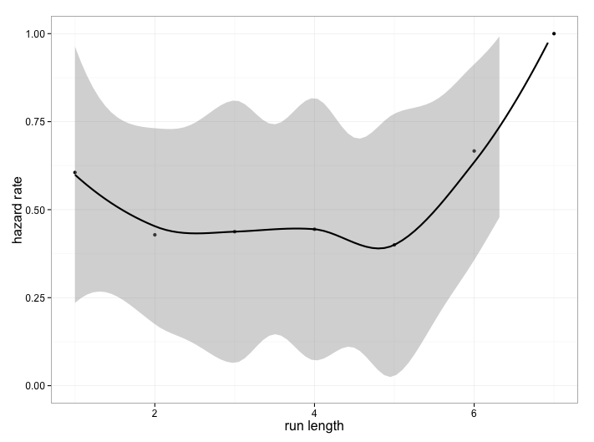
Source: please provide a source (Verdana, 9, centered, spacing after paragraph – 12)

The length of the paper is limited to 8 pages. Text (Verdana 10, justified alignment, line spacing - single, spacing after paragraph – 6). Text (Verdana 10, justified alignment, line spacing - single, spacing after paragraph – 6).

4 Conclusions

The length of the paper is limited to 8 pages. Text (Verdana 10, justified alignment, line spacing - single, spacing after paragraph – 6). Text (Verdana 10, justified alignment, line spacing - single, spacing after paragraph – 6).

Acknowledgments
Information on acknowledgments and financial support are posted here.

References
References must be listed at the end of the paper in alphabetical order. Do not begin them on a new page unless this is absolutely necessary. Authors should ensure that every reference in the text appears in the list of references and vice versa.
Please pay attention to correct format of your reference list.
Example for book reference:
Green, H. (1993). Econometric Analysis, 2nd ed. New York: Macmillan.
Example for reference of the journal paper:
One author
Goyal, S. K. (2007). An integrated inventory model for a single supplier-single customer problem. International Journal of Production Research, vol. 15(7), pp. 107-101.
Two authors
Johansen, S., Juselius, K. (1990). Maximum Likelihood Estimation and Inferences on Cointegration with applications to the demand for money. Oxford Bulletin of Economics and Statistics, vol. 52(2), pp. 169–210.

More than two authors (do not use et al. in References)
Caporale, G. M., Rault, C., Sova, A. D., Sova, R. (2015). Financial development and economic growth: Evidence from new European Union Members. International Journal of Finance & Economics, vol. 20(1), pp. 48-60.
Example for reference of the paper in the conference proceedings or compilation book:
Arrow, K. J. (1991). Accounting for the Slowdown. In: Kosters, M., ed., Workers and Their Wages. Washington, DC: American Enterprise Institute Press, pp. 107-145.
Example for reference of the working paper:
Gropp, R., Moerman, G. (2003). Measurement of Contagion in Banks' Equity Prices. ECB Working Paper, vol. 297.
Example for reference of the legal document:
IFRS 13. Fair Value Measurement. IASB, 2011.
Example for reference of the public report:
BIS (2011). Basel III: A global regulatory framework for more resilient banks and banking systems. Retrieved from: http://www.bis.org/publ/bcbs189.pdf.

